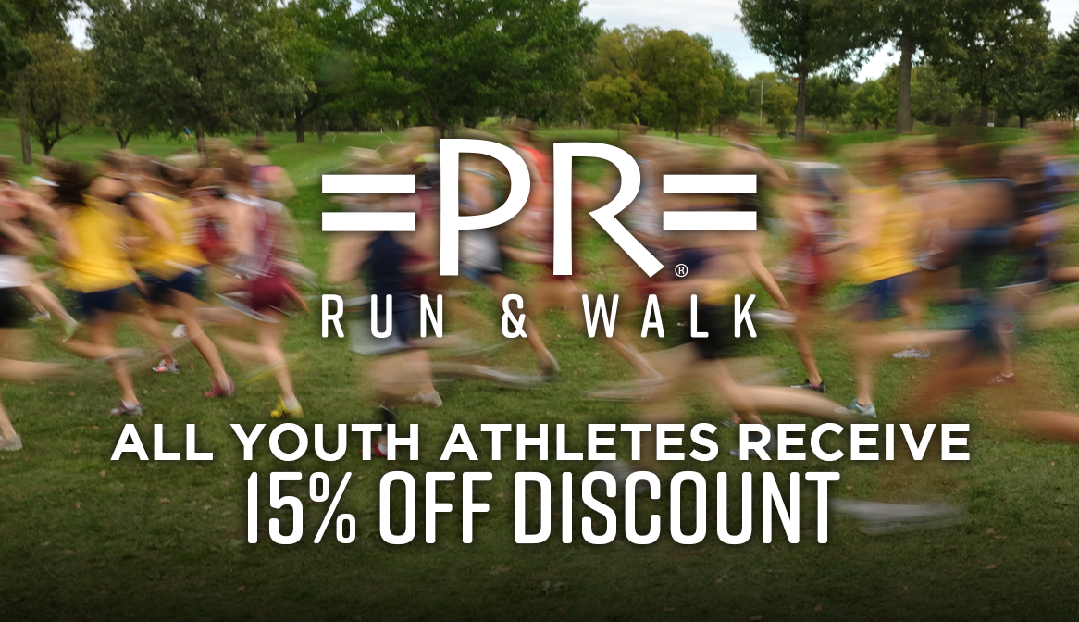
FPYC Sports

Your Partnership with =PR=
- XC Spikes Available and Trainers
- Youth Receive 15% off year round.
- Free video gait analysis and shoe clinic which helps to ensure an appropriate shoe to:
- increase biomechanical efficiency
- minimize injuries
- maximize comfort
- Special student athlete discounts on entire purchase
- Every shoe purchased earns $5 towards your high school of choice
- Special on socks and sport bras
- In store and virtual fittings available

prrunandwalk.com…

Student
Athlete Discount
15% OFF
Online &
In-Store

Exclusions apply. Not valid on gift cards, previous purchases, or with other discounts or promotions. In cases where more than one discount may be relevant, greater discount applies. Not valid on certain key footwear models from Adidas, Asics, Brooks, Hoka, Mizuno, New Balance, Nike, and Saucony. Valid in-store and online.

Earn $$ For Your Team

We make a $5 contribution to your team for every pair of shoes purchased in name of your
high school.

Anyone can purchase their shoes at =PR= and have $5 donated to the school of their choosing – not just athletes. Get the word out to classmates, friends, family, and neighbors!

Your partnership with =PR=
Free T-Shirt
With a minimum purchase of $25 in-store or online with school code.

*$5 off sports bras with shoe/ spike purchase

*Spike pins available

prrunandwalk.com…

